**• List the features of ES6**

**Ans**. a) **let** and **const** for block-scoped variable declarations

b) Arrow functions (=>)

c) Template literals (`Hello ${name}`)

d) Rest and spread operators (...)

e) Promises (for async programming)

f) Modules (import, export)

g) Map and Set data structures

h) Iterators and generators

i) for...of loop

**• Explain JavaScript let**

**Ans. let** is a blocked scope variable that can’t be redeclared within the same scope but can be updated.

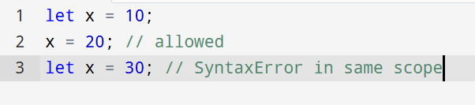

**• Identify the differences between var and let**

**Ans.**

|  |  |
| --- | --- |
| **var** | **let** |
| Function Scoped | Blocked Scoped |
| Redeclaration is allowed in  same scope | Redeclaration is not allowed in same scope |
| Used in Older JS versions | Used in Modern JS versions |

**• Explain JavaScript const**

**Ans. const** is used to declare block-scoped constants, which must be initialized during declaration. It cannot be reassigned, but if the value is an object or array, its properties can be changed.

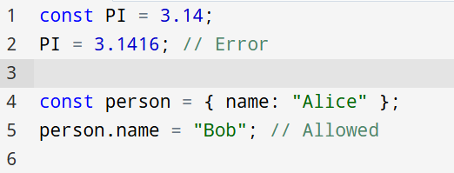

**• Explain ES6 class fundamentals**

**Ans.** 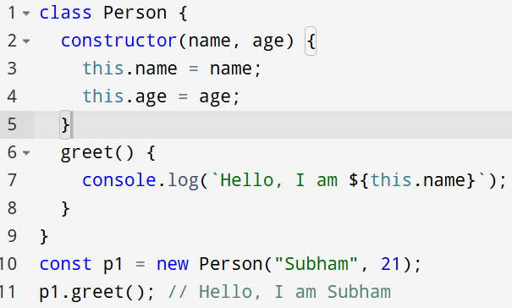

**• Explain ES6 class inheritance**

**Ans.** 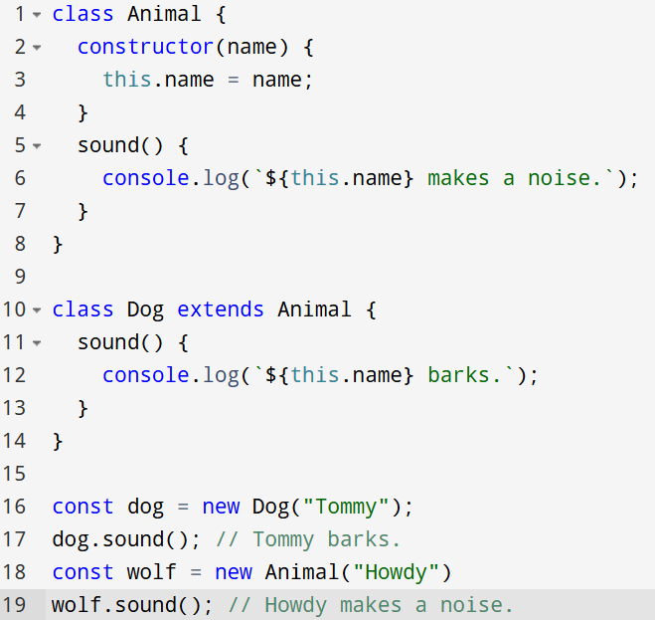

**• Define ES6 arrow functions**

**Ans.** Useful in callbacks and functional programming.



**• Identify set(), map()**

**Ans.** Set is the collection of unique values.

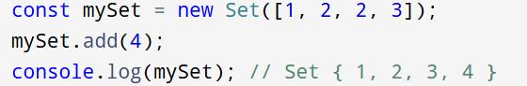

Map is the key-value pairs where keys can be of any type.

